Project: Fast Migrate

COMP 3100

Professor: Dr. Amilcar Soares

Team 16

Ellodie Ha soon 201820248

Hans Ramasamy 201819943

Mohammad Hasan 201858685

**(a) Introduction**

Our main datasets originates from the World Happiness Report, which ranks countries by happiness levels from Gallup World Poll. Experts from different fields recognise that well-being is crucial in the progress of a nation. So, we shall apply these happiness indicators to develop a tool for informing people in decision-making such as migration. Another potential user is a student who is interested in studying abroad, but has difficulties in choosing a country. Who does not seek happiness? We believe that it plays a crucial role when deciding where to move. The dataset consists of scores and rankings of different countries based on answers to surveys from nationally representative samples, which then use Gallup weights to make estimates representative. The happiness score estimate is affected by the following factors: economic production, social support, life expectancy, freedom, absence of corruption and generosity.

We plan to build a dashboard and implement a world map with different colors corresponding to levels of happiness. Data visualization including bar charts, graphs and rankings shall be designed to help users in comparing and deciding between countries. An account feature is to be integrated to save users time from having to perform the same searches several times.

**(b) Proposal**

With the overwhelming number of possibilities that the world has to offer, immigration can be a challenging decision for people interested in settling in foreign countries. Fast Migrate is the web application our team will work on to bring relevant information of countries around the world all in one place. Whether it is global rankings, happiness scores, cost of living index, employment or crime rates among others, we want to ease the problem of looking all over the internet by saving users time and searches. Moreover, we will provide statistics with presentation of requested data to users interested in analyzing trends or contrasting between countries.

Unfortunately, our main dataset consists of happiness only and might not be sufficient for users looking for other criteria while evaluating their choice of destination. Hence, we consider getting access to a third-party API, which will complement our original dataset and provide the following factors: cost of living index, quality of life index, employment rates, crime rates, health care index, pollution index.

Hence, our goal is to deliver a web application targeted to people seeking information about different countries, designed for, but not limited to immigration. Our team aims to achieve all the unique functionalities of Fast Migrate without compromising on aesthetics or website performance by the end of the third iteration.

**(c) Functionalities**

* The user get the information of a particular country he/she desires to immigrate to by inputting the name of the country.
* The user can input a criteria they value most to get the rankings of countries accordingly, such as sorting by low crime rate or high employment level.
* The user can create an account, login and save its progress and search history.
* The user can get a colorized overview of all countries by a world map with each country having a specific color depending on its happiness level, shown below:

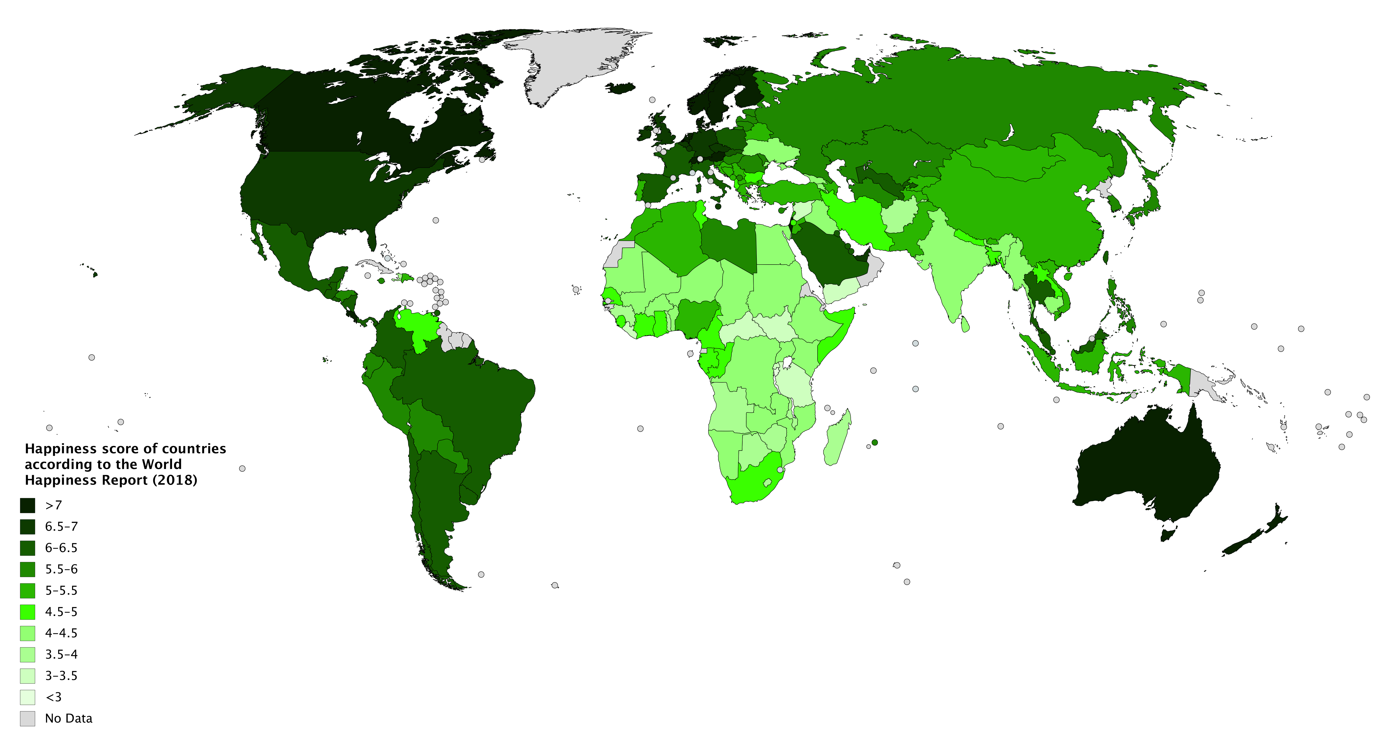

* The user can compare different factors (happiness, employment level, living cost, crime rate, GDP, etc.) of two countries of their choosing through charts, for example: